Mautic Social Login Guide
With Mautic's Social Login, users can easily sign in via their favorite social platforms like Twitter, Facebook, or LinkedIn. The social login feature automatically pre-fills forms with profile data and updates or creates new contacts in Mautic, streamlining the user experience.
Before You Begin: Setup Requirements
Before enabling social login, make sure you have created social media apps on the platforms you want to integrate:
- X-Developer
- Facebook
- LinkedIn
Once these apps are set up, you're ready to connect them to Mautic!
Step 1: Authorizing Social Media Plugins
Before you can use social login, each social media plugin needs authorization. Here’s how to do it:
To get started with social login, you’ll first need to authorize each plugin:
- Copy the Callback URL:
After creating your social app, the platform will ask for a Callback URL.
  - Go to Mautic's plugin configuration window and copy the Callback URL provided there.
  - Paste it into the appropriate field in your social app setup.
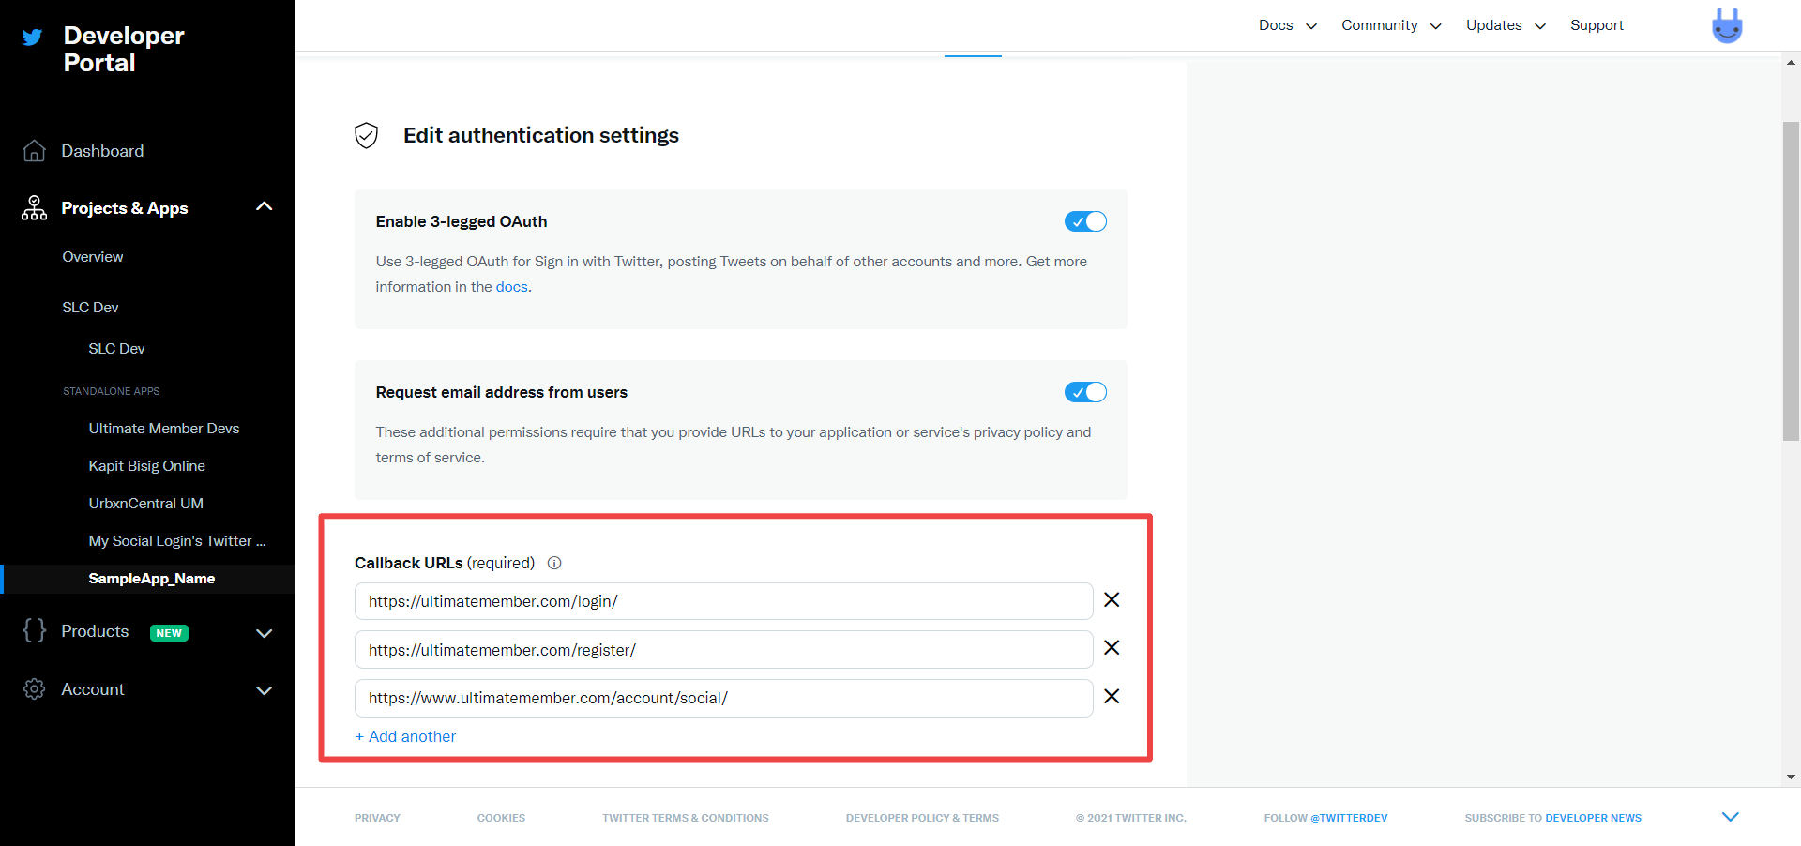
- Add Your API Keys:
Now that your social app is set up:
  - Copy the API Key (Client Key) and API Secret (Client Secret) from the social platform.
  - Paste these keys into the relevant fields in the Mautic plugin configuration.
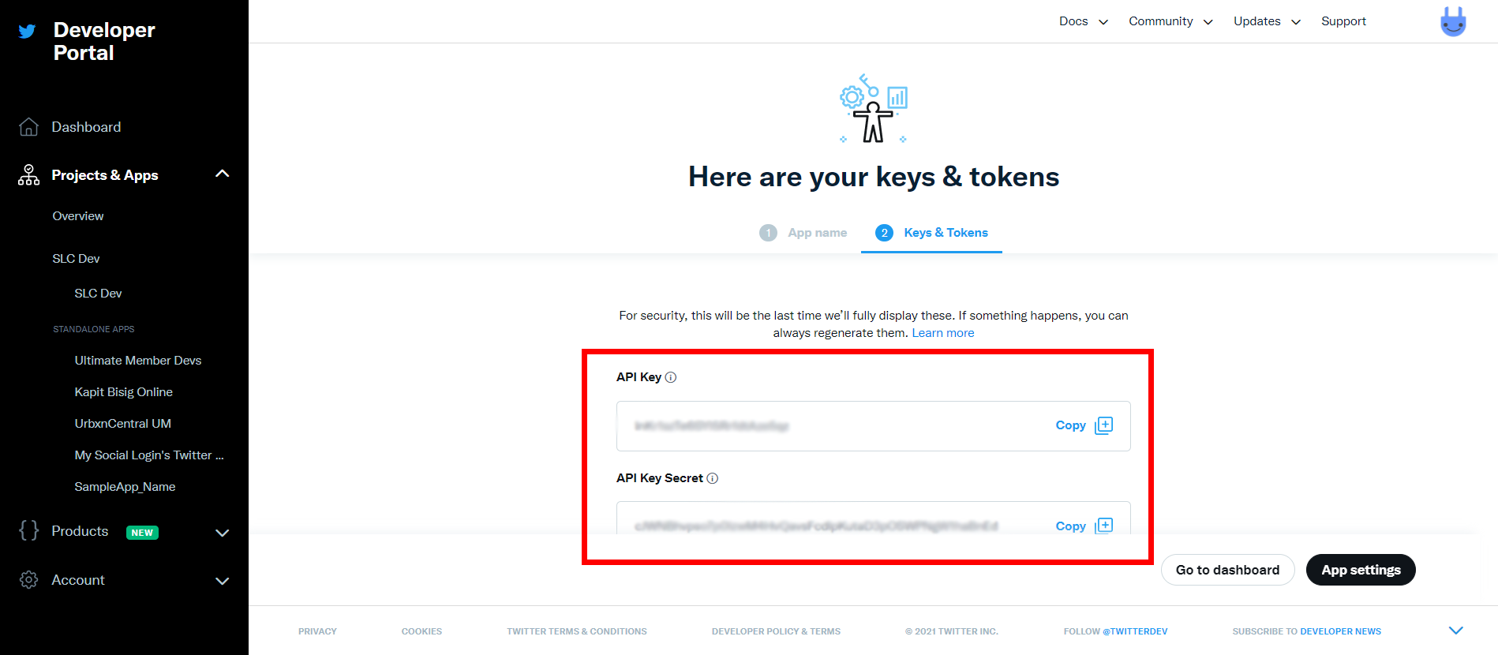
- Authorize the Plugin:
  - In the Mautic plugin configuration, click Authorize.
  - Ensure the plugin is marked as Published by toggling the option to “Yes”.
  - Save your configuration to complete the setup.
Example Image: Mautic plugin configuration screen showing authorized status.
Tip: You can manage each social network under its respective tab in Mautic’s plugin settings. Make sure each network is fully authorized by adding the required API credentials.
Step 2: Adding Social Login Buttons to Forms
Once your plugins are authorized, you can add social login buttons to your Mautic forms.
- Create or Edit a Form:
Go to the Forms section in Mautic and either create a new form or edit an existing one.
- Add the Social Login Field:
Select the Social Login field from the form builder. Buttons for all authorized social platforms (e.g., Twitter, Facebook, LinkedIn) will automatically appear.
- Pre-fill Form Fields:
When users log in using their social accounts, Mautic will attempt to automatically fill in fields like Name or Email based on their social profile.
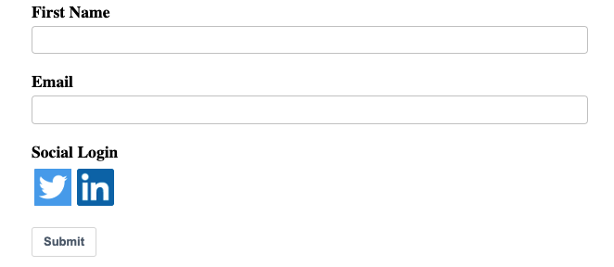
Note: Only the buttons for plugins you’ve authorized will work in the form. Ensure all integrations are configured correctly for a smooth user experience.

Step 3: Configuring Features and Mapping Contact Fields
Once the plugin is authorized, you can customize how Mautic handles the incoming social profile data.
- Map Social Profile Fields to Mautic Fields:
Under the Contact Field Mapping tab in the plugin settings, map the fields from the user’s social profile (e.g., Email, Name) to the appropriate Mautic contact fields.
  - You only need to map fields that are relevant to your form.
  - Unmapped fields will not be used to update or create contacts in Mautic.
Example: Map "First Name" from Facebook to "First Name" in Mautic's contact fields.

Supported Social Profile Fields
Each platform provides different user data fields. Here's a quick reference of the fields you can map:
Twitter
- Profile Handle, Name, Location, Description, URL, Time Zone, Language, Email.
Facebook
- First Name, Last Name, Name, Gender, Locale, Email, Profile Link.
LinkedIn
- First Name, Last Name, Maiden Name, Formatted Name, Headline, Location, Summary, Specialties, Positions, Public Profile URL, Email Address.

